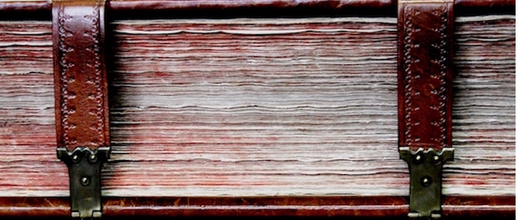
XX
MIĘDZYNARODOWA
I OGÓLNOPOLSKA
KONFERENCJA ONOMASTYCZNA

KRAKÓW
2016

FORM I:
PARTICIPATION AND PAPER APPLICATION (deadline: 15th April 2016)
Name and surname
Title
Institutional affiliation
Postal address
Telephone number
E-Mail address
Paper’s title
An abstract in both Polish and English (between 500-1000 characters)
Language that the paper will be presented in
Equipment requirements

Conference organisers will contact the authors of the selected papers. The presentation time is 20 minutes + 10 minutes for a discussion / paper.

CONTACT
XX MiOKO
Website: xxmioko.ijp-pan.krakow.pl
E-mail address: xxmioko@ijp-pan.krakow.pl

Instytut Języka Polskiego PAN
al. Mickiewicza 31
31-120 Kraków
tel. +48 (12) 632-56-92, ext. 345, 314

Organisational Committee Chair:
prof. dr hab. Barbara Czopek-Kopciuch

Secretaries:
prof. nadzw. dr hab. Małgorzata Magda-Czekaj
malgorzata.magda@ijp-pan.krakow.pl
mgr Paweł Dudek
paweldudek2@interia.pl

