
XX
MIĘDZYNARODOWA
I OGÓLNOPOLSKA
KONFERENCJA ONOMASTYCZNA

KRAKÓW
2016

FORM II:
Fees, meals and accommodation payments (application due date 30th April 2016).
Name and surname
Institutional affiliations
Postal address
Telephone number (including country code)
E-mail address
Comments and requests

CONFERENCE FEE
The conference fee for a participant is PLN 400.00, and PLN 300.00 for students and PhD students. The fee includes organisational costs, participation in the ceremonial dinner, and also the preparation of the after-conference publication. The full payment should be sent to the IJP PAN account by the 30th April 2016.

The payment should be sent to the following account:
25 1130 1150 0012 1267 3820 0001, SWIFT code: GOSKPLPW
with an annotation: Uczestnictwo w XX MiOKO

ACCOMMODATION AND MEALS RESERVATION
The conference fee does not include accommodation or meals costs.

Accommodation reservation
We are pleased to offer accommodation at the Jagiellonian Univeristy Guesthouse, ‘Przegorzały’. You can choose from single, double and triple rooms.
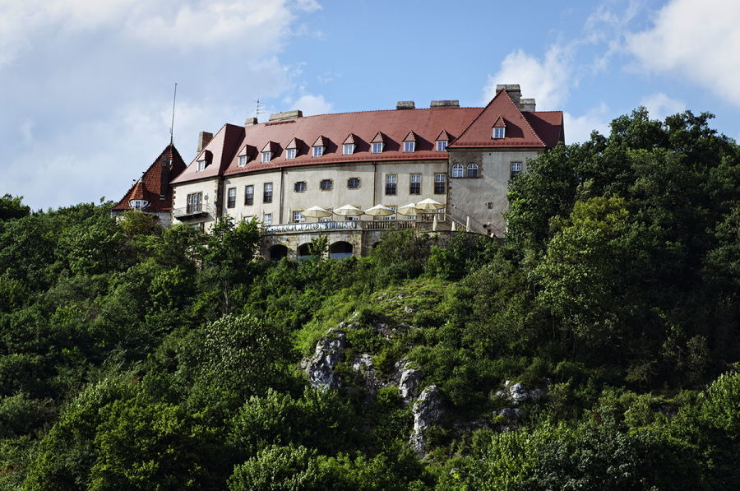
‘Przegorzały’ UJ Guesthouse is situated five kilometres from the Kraków city Centre, seven kilometres from the Kraków Airport and three kilometres from the A4 motorway (convenient if you want to travel to Wieliczka, Wadowice, Bochnia, Zakopane, Silesia or any other direction in Poland). The guesthouse is situated in a stunning location: on a hill on the border of Lasek Wolski (Wolski Forest), and it is a fantastic place for work as well as leisure.
http://www.dg.uj.edu.pl/przegorzaly/o-nas

Breakfast is not included.

Room type: | Price
Single room with bathroom  - double bed  - single bed | PLN 160  PLN 150
Double room with bathroom | PLN 180
Triple room with bathroom | PLN 210
Quadruple – a studio (two rooms with a shared bathroom) | PLN 240
A suite in the Bastille (three rooms, kitchen, bathroom, toilet)  - single suite  - double suite  - triple suite  - quadruple suite | PLN 350  PLN 400  PLN 450  PLN 500

Accommodation 20.09.2016 / 21.09. (Tuesday/Wednesday) | YES* | NO
Accommodation 21.09.2016 / 22.09. (Wednesday/Thursday) | YES | NO
Accommodation 22. 09.2016 / 23.09. (Thursday/Friday) | YES | NO

* Cross out the unnecessary
Meals reservation
Meals can be ordered from a restaurant situated in the Dom Gościnny (Guesthouse) building. The prices are as follows: breakfast: approx. PLN 20.00; lunch approx. PLN 27.00; supper: approx. PLN 27.00.
20.09.2016 (Tuesday) | supper | YES * | NO
21.09.2016. (Wednesday) | breakfast | YES | NO
 | lunch | YES | NO
 | supper | YES | NO
22.09.2016 (Thursday) | breakfast | YES | NO
 | lunch | YES | NO
 | Ceremonial dinner
23.09.2016 (Friday) | breakfast | YES | NO
 | lunch | YES | NO
 | supper | YES | NO

* Cross out the unnecessary

Information for the VAT invoice:
(Important: a person or an institution can be provided with a VAT invoice only if the payment has been sent directly to the IJP PAN account)
VAT invoice declaration
Please provide me with a VAT invoice | YES* | NO

* Cross out the unnecessary

Name of the institution that the VAT invoice should be prepared for

Full address (including post code and country name)
Company registered number
Address that the VAT invoice should be sent to

CONTACT
XX MiOKO
Website: xxmioko.ijp-pan.krakow.pl
E-mail address: xxmioko@ijp-pan.krakow.pl

Instytut Języka Polskiego PAN
al. Mickiewicza 31
31-120 Kraków
tel. +48 (12) 632-56-92, ext. 345, 314

Organisational Committee Chair:
prof. dr hab. Barbara Czopek-Kopciuch

Secretaries:
prof. nadzw. dr hab. Małgorzata Magda-Czekaj
malgorzata.magda@ijp-pan.krakow.pl
mgr Paweł Dudek
paweldudek2@interia.pl

